**A warm welcome to Runnymede Runners**, you’ve made a great decision. Whether you are looking to get fitter, run longer, train for an event, or just to socialise and get support from friendly people, or indeed all of these, then we are the Club for you.

We cater for **all** running abilities, as long as you are over 18, from beginners to seasoned athletes, and our running activities and training schedules are structured to support each individual goal.

In summer we run and train in Windsor Great Park, from Savill Gardens, and in winter from the Thames Side Brewery in Staines.

Our members only Facebook page tends to be our internal Club communication platform, keeping members informed on training plans, activities and news within the Club, we also have a Runnymede Runners Strava group, so you can get loads of kudos from other members.

We have a website [www.Runnymederunners.com](https://d.docs.live.net/A308087BFA83FB63/www.Runnymederunners.com) which will also give you a lot of background information and a race calendar, which you can sync to your mobile phone.

The [My clubhouse](https://runnymederunners.myclubhouse.co.uk/SignIn) application is mainly used for membership and club social event payments, the training calendar, and kit purchases.

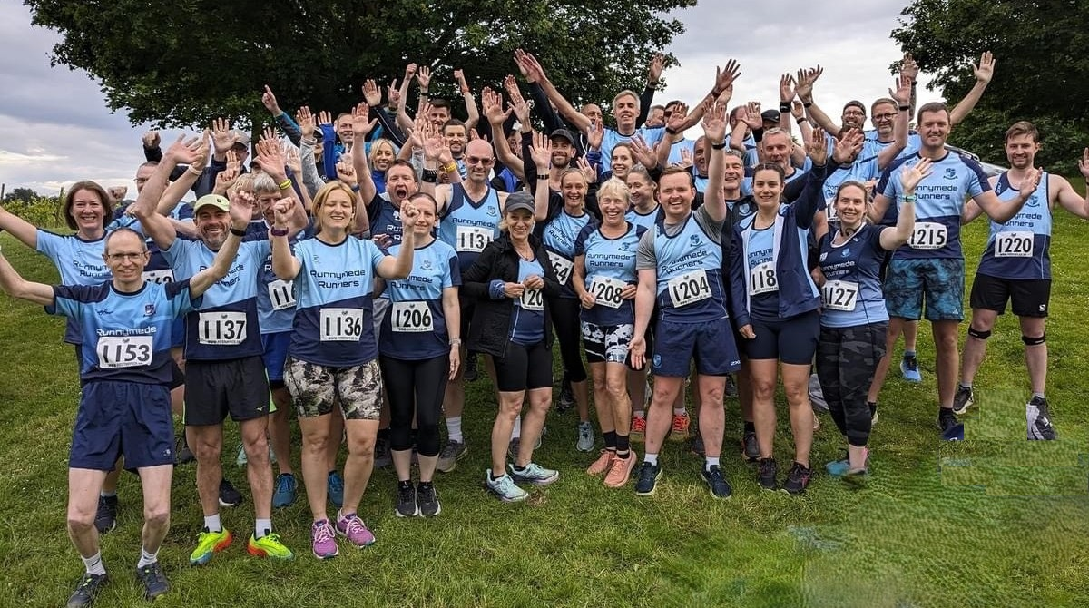

**What does your Membership get you?**

1. A coached session led by England Athletics qualified Club members on a Tuesday evening (7-8pm) **catering for all abilities**, with the aim of improving your fitness and stamina.  
     
   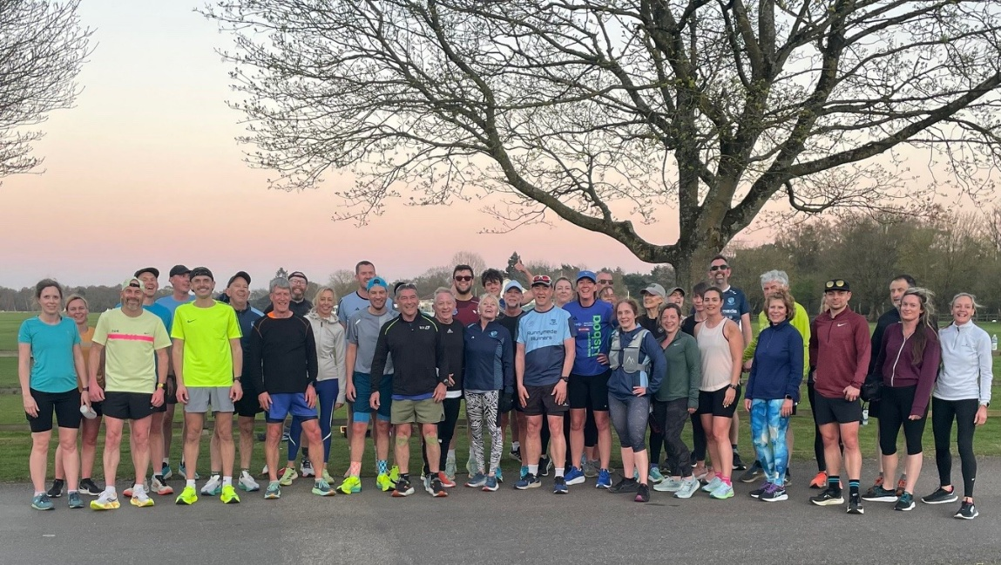
2. A Thursday group run, again between 7-8pm, between 4-8 miles, depending on ability, with a route nominated by the Club Captain each week. We will initially place you with runners of a similar speed, so you feel comfortable and get to know the routes. In the Winter after the run, we tend to visit the Thameside Brewery for a curry and or a beverage. In Summer we often go to a local pub in Englefield Green.
3. In the Summer months we run a timed [5 mile handicap](https://www.runnymederunners.com/summer-handicap/) on the last Thursday of the month through the Great Park, you set a time with your first run, and then essentially on the next one you try and beat it with the most improved receiving warm congratulations and a trophy.
4. A Sunday social run 5-10 miles (unless there is a significant race taking place) which tends to be at a gentler pace, often stopping for photos, enjoying the scenery, and making sure the group stays together, followed normally by coffee and maybe breakfast.
5. During the winter months we offer a coached winter track session at the Thames Valley track in Eton from October to March, again suitable for all abilities, although there is a charge for the track hire.

1. We host our own flagship event in July called the [Runnymede Runners Summer Festival Relay](https://www.runnymederunners.com/relays/) in Windsor Great Park, which will likely involve you in running and/or helping, but we also encourage families to come along to support you while enjoying the sunshine
2. We are part of the friendly [MABAC league](https://mabacleague.org.uk/2025/) (Mathew Arnold + British Aircraft Corporation, who were the founders). This gives you 10 cross country runs throughout the year (normally 5 miles, although there are shorter options) in picturesque parts of the Surrey countryside on a Sunday morning, or in the summer on a Tuesday evening, **for free** as part of the membership. All runners score points for the club in a friendly league table, and can involve cake, coffee and a laugh at the end.
3. With the England Athletics membership, you also get the opportunity to run in the Surrey League, 4 races across Surrey, usually around Saturday lunchtime, in October to February **also for free**, and likewise cake, coffee and fun feature highly.
4. With the EA membership you also get discounts to most races, running apparel and accessories, and importantly support the organisation which affiliates our coaches and provides guidance and support to Runnymede Runners on how to manage a successful running club.
5. Most Importantly though, in joining Runnymede Runners, you become part of a positive support team, both in training with the club and at many races. Often you can travel together with other members in the distinctive blue vests who will also be cheering you on, and buying you a celebratory drink (maybe) in the pub afterwards.

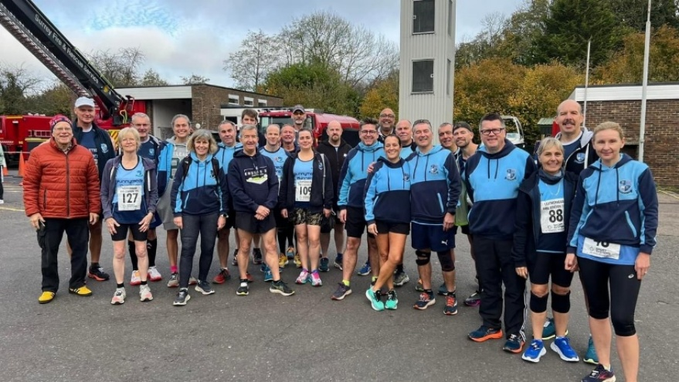

**Social Events**

1. A pasta party the Friday night before the London marathon, this is our end of season awards night, which doesn’t involve running, but eating, dancing and maybe the odd drink.
2. A Christmas party normally early December which again involves eating, drinking and dancing, maybe there is a theme here.
3. We have also partaken in other social activities such as a paint and sip night, paddleboarding, kayaking and quiz nights.
4. A group of people sitting at a bar

   AI-generated content may be incorrect.As a mix of social and running, we occasionally travel aboard for a race, this year a large party of mixed ability runners went to Lisbon to enjoy the 10k or half marathon, as well as the local hospitality.

**Other Points**

* **Club kit** is available for purchase from our kit secretary (through the [myclubhouse portal)](https://runnymederunners.myclubhouse.co.uk/SignIn) wearing club colours at races makes it easily recognisable that you are a member of a great club, so it’s easier for spectators to spot you and cheer you on during the run.
* **Windsor Great Park Membership** – You may consider joining the “[Friends of Windsor Great park](https://www.windsorgreatpark.co.uk/membership/membership-friends-of-windsor-great-park/)” although an initial expensive outlay (circa £100, although you can buy a joint membership with a friend – who doesn’t have to live at the same address) it will give you free carparking in all the park car parks for 12 months.
* **Club Championships** – a nominated race each year for 10k, half marathon, 10 mile, and the Windsor MABAC (and any official marathon) is a chance to show off your running ability, with club prizes for best in age group. There is also a parkrun improvers championship which runs all year. All the details are here - <https://www.runnymederunners.com/club-championships/>
* **Club Calendar – for local races/club championships –** These are highlighted on the website on the calendar section <https://www.runnymederunners.com/events/> you can link your own calendar to the page so you automatically receive updates.
* **Parkrun:** There are many parkrun enthusiasts in the Club, and in addition to the parkrun improvers championship there is a more informal meet up, which can be for a local event or maybe further afield, the location of which can heavily rely on the quality of the local breakfast.

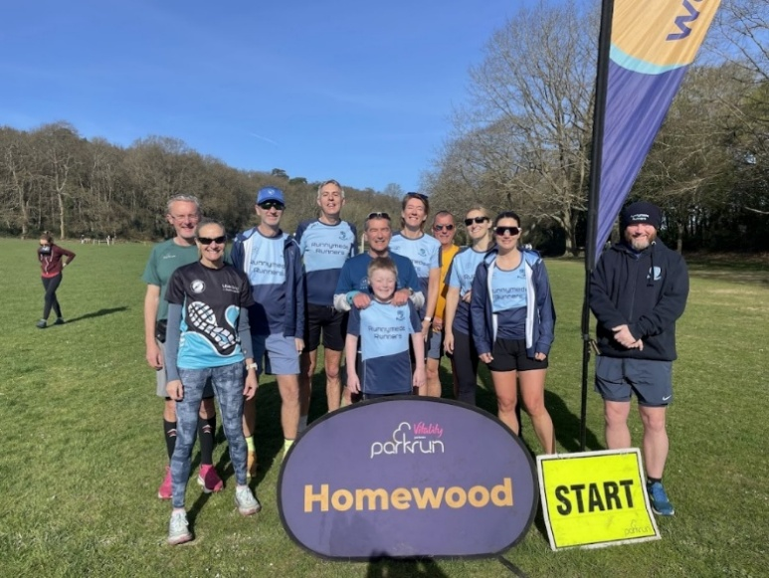

This note is just a guide to the many activities and support the Club offers, if need further information, clarification or have any concerns please don’t be shy and approach any of the Club Coaches, Committee or Club Captain who will be very happy to help you.

**So again, Welcome ! and we hope you enjoy all the Club has to offer.**